

**PROJECT BASED LEARNING REPORT ON**

# CLASSROOM ATTENDANCE SYSTEM USING FACE RECOGNITION

SUBMITTED TO THE SAVITRIBAI PHULE PUNE UNIVERSITY, PUNE

IN THE PARTIAL FULFILLMENT OF SECOND YEAR OF ENGINEERING

**IN**

## Computer Engineering

### **BY**

|  |  |
| --- | --- |
| 1. SAHIL SINGH | **S1902104354** |
| 2. SOMDATT KABI | **S1902104356** |
| 3. VARAD HAJARE | **S1902104369** |
| 4. SOHAM WALHEKAR | **S1902104373** |
| 5. RAJESH YEDE | **S1902104375** |

### **UNDER THE GUIDANCE OF**

**DR. SANDHYA O. AHIRE**



ACADEMIC YEAR: 2024-25

**CERTIFICATE**

This is to certify that Project Report entitled

***CLASSROOM ATTENDANCE SYSTEM USING FACE RECOGNITION***

Submitted by

Mr. Sahil Singh (S1902104354)

Mr. Somdatt Kabi (S1902104356)

Mr. Varad Hajare (S1902104369)

Mr. Soham Walhekar (S1902104373)

Mr. Rajesh Yede (S1902104375)

Is the record of Bonafide work carried out by them in partial fulfillment of the requirement for the award of the Degree of **Bachelor of Engineering (Computer Engineering ),** as prescribed by the Savitribai Phule Pune University in the Academic Year 2024-25.

This project report has not been earlier submitted to any other Institute or University for the award of any degree or diploma.

**Dr S O Ahire**  **Dr. Shashikant V. Athawale**

Internal Guide Head of Department

Department of E&TC Engg. Department of Computer Engg.

**Dr.D.S.Bormane**

Date : Principal ,**AISSMS College of Engineering, Pune**

**ACKNOWLEDGEMENT**

It is our great pleasure in expressing sincere and deep gratitude towards our guide **Dr. S. O. Ahire,** Electronics & Telecommunication Engineering Department for her valuable guidance and constant support throughout this work and help to peruse additional studies in computer engineering

We take this opportunity to thank Head of the Department **Dr.** **Shashikant V. Athawale** and all staff members of department of Computer Engineering , AISSMS COE Pune, for cooperation provided by them in many ways.

The motivation factor for this work was the inspiration given by our honorable principal **Dr. D. S. Bormane.**

Lastly, we are thankful to those who have directly or indirectly supported our work.

Sign Sign Sign

**Sahil Singh Somdatt Kabi Varad Hajare**

Sign Sign

**Soham Walhekar Rajesh Yede**

**ABSTRACT**

In an era where automation and efficiency are critical, traditional attendance tracking methods such as manual registers and ID cards are increasingly inefficient and prone to errors. This project introduces an **Attendance Marking System** leveraging **Python, Flask, SQLite, and OpenCV** to deliver a secure, contactless, and automated solution for **attendance management**.

The system employs real-time face recognition by capturing facial images via a camera, utilizing the **Haar Cascade classifier** for face detection and the **Local Binary Patterns Histograms (LBPH) algorithm** for recognition. It compares captured facial data against a pre-trained model stored in a lightweight SQLite database, ensuring accurate identity verification. **Integrated with Dropbox for cloud-based data synchronization**, the system allows seamless updates to the **allowed students list** and attendance records, accessible through a user-friendly **Flask web interface**.

Designed specifically for **attendance tracking**, this solution enhances security, reduces manual effort, and provides **downloadable CSV reports**, making it an efficient tool for **educational institutions** and similar settings. By combining computer vision and web technologies, the project offers a robust, scalable, and real-time **attendance management system**.

**INDEX**

|  |  |  |
| --- | --- | --- |
| **CHAPTER**  **NO.** | **TITLE** | **PAGE NO.** |
| 1 | Introduction | 6 |
| 2 | Literature Review | 7 |
| 3 | Aim and Objectives | 8 |
| 4 | Process Flow Diagram and working | 10 |
| 5 | Test Results and Analysis | 12 |
| 6 | Advantages | 15 |
| 7 | Disadvantages | 15 |
| 8 | Future Scope | 16 |
| 9 | Conclusion | 16 |
| 10 | References | 17 |

1. **INTRODUCTION**

Face recognition technology has emerged as a transformative and powerful tool across a diverse array of applications, revolutionizing fields from security systems to tailored user experiences. Unlike traditional authentication methods—such as passwords, PINs, or ID cards—which are vulnerable to security breaches, theft, or human error, face recognition delivers a seamless, contactless, and highly secure alternative that leverages the uniqueness of an individual’s facial features.

The process begins with the capture of an image or video stream through a camera, followed by the extraction of distinctive facial characteristics using sophisticated artificial intelligence (AI) models. These models analyze intricate details—such as the distance between eyes, nose shape, or jawline contours—and convert them into a digital signature. This signature is then compared against a database of stored facial profiles to verify identity. If a precise match is detected, access is granted swiftly; if not, it is denied, ensuring robust protection.

This cutting-edge technology boasts a broad spectrum of applications, including:

* **Security & Surveillance**: Bolstering safety by enabling real-time monitoring of public spaces, restricted zones, and critical infrastructure with unparalleled precision.
* **Attendance Tracking**: Streamlining presence verification in educational institutions, workplaces, and large-scale events, eliminating manual processes and reducing errors.
* **Smart Devices**: Enhancing user convenience through face-based authentication for unlocking smartphones, laptops, and integrating with smart home systems for personalized control.
* **Personalized Marketing**: Empowering businesses to analyze customer demographics and behaviors in real time, delivering customized recommendations and improving engagement.

**2. LITERATURE REVIEW**

Face recognition technology has progressed significantly, evolving from rudimentary pattern recognition techniques to sophisticated models that deliver exceptional accuracy and efficiency. This advancement has enabled a wide range of applications.

**Early Approaches:**

* **Eigenfaces & Fisherfaces (PCA-based Methods)**: Pioneering techniques that employed mathematical projections, such as Principal Component Analysis (PCA), to reduce facial data into key components for matching. These laid the groundwork for modern recognition systems.
* **Local Binary Pattern Histogram (LBPH)**: A computationally efficient method that analyzes local texture patterns in grayscale images. Adopted in this project for its effectiveness in low-complexity, real-time applications, LBPH excels at distinguishing facial features under varying conditions, making it ideal for attendance tracking.

**Modern Approaches in Context:**

* **Haar Cascade Classifier (OpenCV)**: Integrated into this system, this technique leverages a cascade of simple features to rapidly detect faces in video frames. While not a deep learning model, its speed and reliability make it a cornerstone for initial face localization in our implementation.
* **LBPH Face Recognizer (OpenCV)**: Building on early LBPH concepts, this modern adaptation within OpenCV trains on captured facial data to create a recognition model. It maps faces into a feature space optimized for comparison, ensuring precise identity verification with minimal computational overhead.

**Role of Supporting Technologies:**

* **SQLite**: A lightweight, serverless database employed in this system to securely store facial encodings, student details (e.g., name, roll number), and attendance records. Its simplicity and efficiency enable rapid data retrieval and management, supporting real-time operations.
* **Flask**: A flexible, Python-based web framework that powers the system’s intuitive interface. Replacing heavier frameworks like Django, Flask provides a streamlined backend for handling requests—such as syncing student data, adding new faces, or viewing attendance—while seamlessly integrating with OpenCV and SQLite.
* **Dropbox Integration**: A standout feature, this cloud service synchronizes the allowed students list and attendance logs (stored as CSV files) in real time. It enhances accessibility and ensures data persistence, allowing administrators to manage records remotely with ease.

By combining the proven LBPH algorithm with Haar Cascade detection, this system leverages OpenCV’s capabilities alongside SQLite’s efficient storage and Flask’s lightweight web framework. Enhanced by Dropbox for cloud connectivity, it delivers a scalable, accurate, and user-friendly solution tailored specifically for automated attendance marking in educational settings.

**3. AIM AND OBJECTIVES**

### **3.1 Problem Statement:**

This project proposes an **attendance marking system** utilizing **Python, Flask, SQLite, and OpenCV** to deliver a **secure, contactless, and automated solution for classroom attendance management**. Traditional attendance methods, such as manual roll calls or ID-based systems, are time-consuming, error-prone, and lack scalability. By integrating face recognition technology, this system aims to streamline the process, enhance accuracy, and provide a robust alternative for educational institutions.

### **3.2 Objectives of the Project:**

1. **Face Detection** – Implement a reliable algorithm to detect faces in real-time using **OpenCV’s Haar Cascade classifier**, ensuring fast and accurate identification of students in a classroom setting.
2. **Feature Extraction** – Utilize the **Local Binary Patterns Histograms (LBPH)** algorithm within OpenCV to extract distinctive facial features, creating a compact and efficient representation for recognition.
3. **Data Storage** – Securely store student details (e.g., name, roll number) and attendance records in an **SQLite database**, maintaining a lightweight and efficient repository for real-time access.
4. **User Authentication** – Compare captured facial features with a pre-trained LBPH model to verify student identity, ensuring only authorized individuals from the **allowed students list** are recognized and marked present.
5. **Web-based Integration** – Develop an intuitive, user-friendly interface using **Flask**, enabling administrators to manage attendance, sync data with **Dropbox**, add new students, and access downloadable CSV reports seamlessly.

**3.3 Methodology:**

**1. Web Interface (Flask):**

- Routes: /, /add_face, /start_recognition, /view_attendance, /sync_students, /add_student

- Templates: index.html, add_face.html, view_attendance.html, sync_students.html, add_student.html

- Handles HTTP requests and renders HTML pages

**2. Face Detection (OpenCV):**

- Haarcascade for face detection

- Handles camera operations

**3. Face Recogniton**

- Face capture and recognition

- LBPH Face Recognizer

**4. Database Layer (SQLite):**

- Tables: attendance, face_data, name_to_id, allowed_students

- Stores student data, face encodings, and attendance records

**5. Cloud Storage (Dropbox):**

- Stores CSV files (attendance records and allowed students list)

- Provides shareable links for attendance records

- Syncs allowed students list

**6. Notification Manager (Tkinter):**

- Displays system notifications

- Runs in background with queue system

- Shows alerts for errors, successes, and timeouts

**4. PROCESS FLOW DIAGRAM OF THE SYSTEM AND ITS EXPLANATION**

**4.1 Process Flow Diagram:**

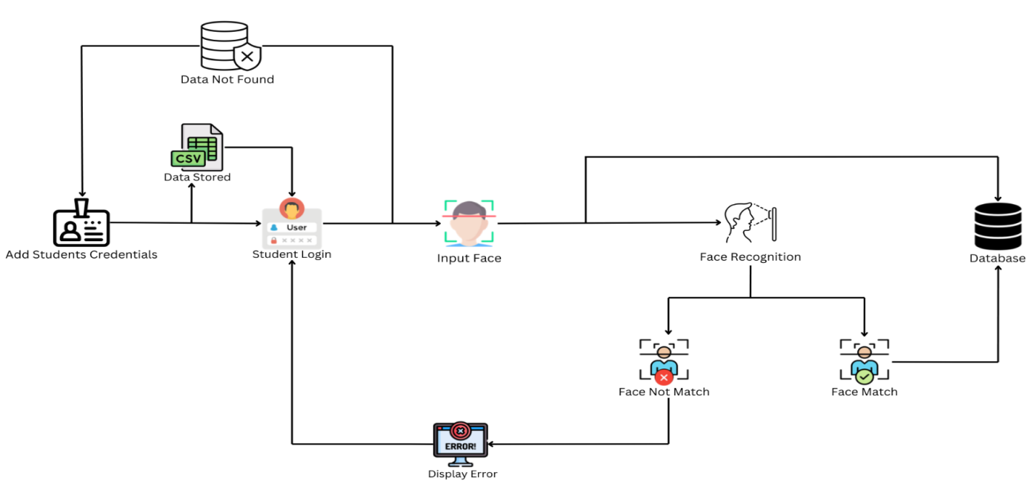

### The Attendance Marking System operates through an automated, secure process designed to manage classroom attendance efficiently using face recognition technology. Security is embedded at every stage to protect data, ensure authorized access, and maintain system integrity. Below is a detailed breakdown of its workflow:

**4.2 Working**

1. **Add Student Credentials**  
   Administrators input student details—**Name** and **Roll Number**—through a Flask web interface. This step requires an **admin password**, verified using **bcrypt hashing**, to prevent unauthorized additions. Credentials are stored in an **SQLite database** under the "allowed_students" table, with a unique constraint on Name and Roll Number combinations to avoid duplicates. The data is then synced to a **CSV file** ("allowed_students.csv") with an auto-generated serial number and uploaded to **Dropbox** using OAuth 2.0 authentication, ensuring encrypted cloud storage and secure remote access.
2. **Initiate Attendance Session**  
   Students do not log in individually; instead, the system is activated via the Flask interface’s **"Start Recognition"** option, accessible only to authenticated administrators. This eliminates student-side vulnerabilities (e.g., credential theft) and centralizes control. The process uses a **time-bound session** (60-second timeout) to prevent prolonged exposure of the camera feed, reducing the risk of external interference.
3. **Image/Video Capture**  
   A camera (webcam or external) captures a **live video stream** in real time, serving as the input for recognition. The system restricts access to the camera feed to the application itself, minimizing the risk of unauthorized recording. A **one-minute timeout** ensures the capture process terminates if no faces are detected, safeguarding against indefinite operation or exploitation.
4. **Face Detection**  
   Using **OpenCV’s Haar Cascade Classifier**, the system detects faces by analyzing patterns in the video stream. This step includes a **minimum face size threshold** (50x50 pixels) to filter out noise or false positives, enhancing detection reliability. The algorithm’s open-source nature allows for regular updates to counter emerging security threats, ensuring robust face localization.
5. **Feature Extraction**  
   Detected faces are processed by the **Local Binary Patterns Histograms (LBPH)** algorithm within OpenCV, which extracts texture-based facial features into a histogram. These features are stored in a **trained model file ("face_trained.yml")**, secured locally and only accessible by the system. The use of LBPH avoids storing raw images, reducing privacy risks, while the model is retrained periodically to remove outdated or unauthorized entries, maintaining data integrity.
6. **Face Recognition / Matching**  
   Extracted LBPH features are compared against the pre-trained model, with identities verified against the SQLite "allowed_students" list. The recognition process uses a **confidence threshold (70)** to ensure high accuracy, rejecting low-confidence matches to prevent false positives.
   * **If a Match is Found**: The student is authenticated as an allowed individual, and attendance is recorded in the SQLite "attendance" table with a **unique ID** (hashed using MD5) and timestamp. A **30-second cooldown** prevents duplicate entries, while the updated CSV file (e.g., "attendance_YYYY-MM-DD.csv") is encrypted during **Dropbox upload** via HTTPS, ensuring secure cloud backup.
   * **If No Match is Found**: The system flags the face as "Unknown" or "Not Authorized," displaying a **notification** (via Flask or Tkinter pop-up) without logging sensitive data. Failed attempts are not stored, reducing the attack surface for unauthorized access attempts.
   1. **TEST RESULTS AND ANALYSIS**

**1. Home Page**

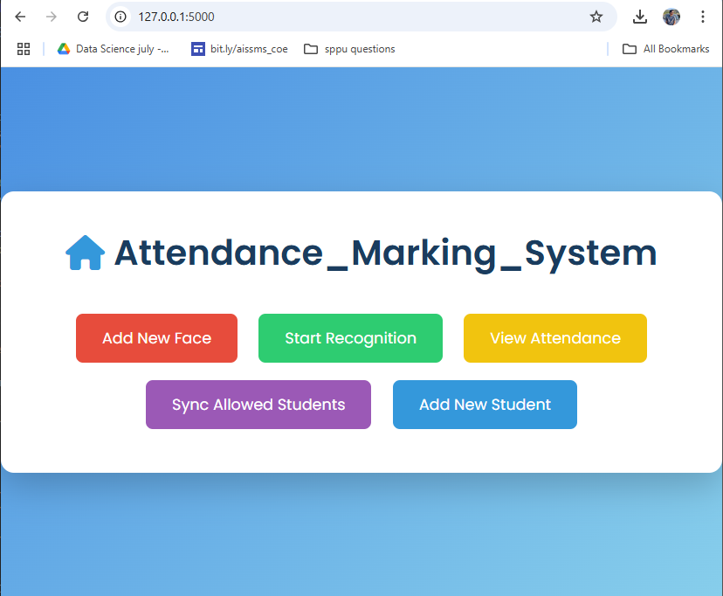

**2. Add Students Credentials:**

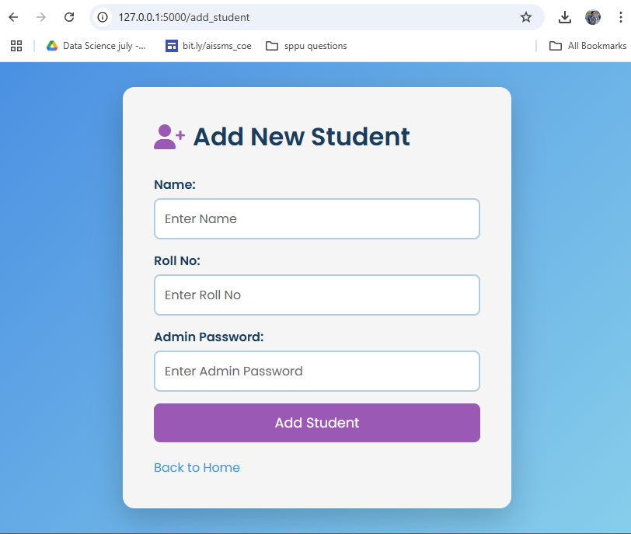

**3. Student Login:**

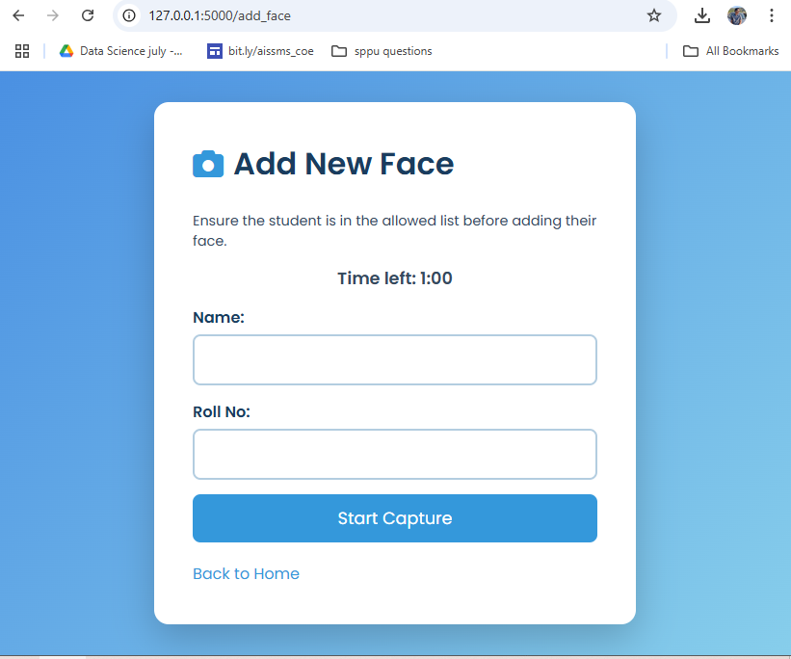

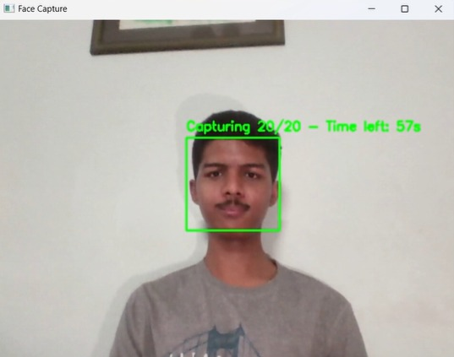

**4. Mark Attendance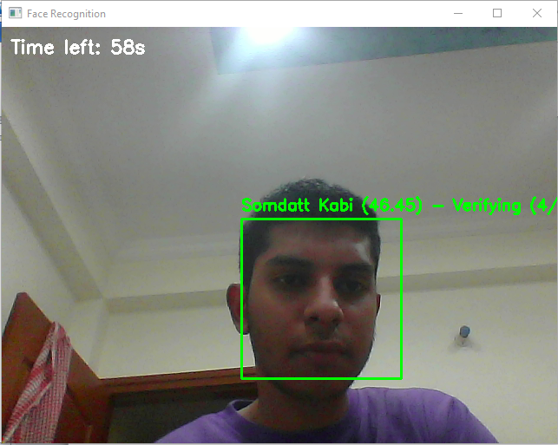 5. View Attendance**

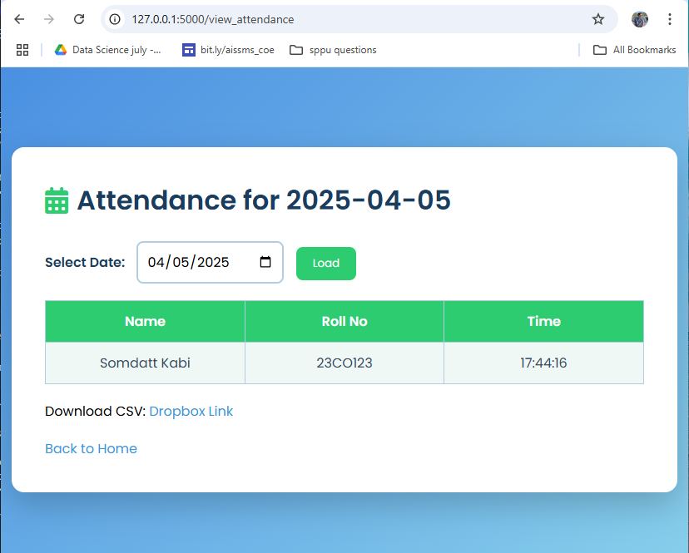

### 

**6. ADVANTAGES**

1. **Robust Security & Seamless Authentication**  
   The system offers a **secure, contactless authentication method** by leveraging  
   unique facial features, eliminating risks associated with password theft, lost ID cards, or manual errors. Integration with an admin-verified "allowed students list" and SQLite’s secure storage enhances protection against unauthorized access.
2. **Rapid & Efficient Processing**  
   With **real-time face detection and recognition** powered by Haar Cascade and LBPH algorithms, the system marks attendance in seconds. The 60-second recognition window and automated CSV generation streamline classroom management, making it ideal for time-sensitive environments.
3. **Intuitive User Experience**  
   Students simply face the camera—no passwords, PINs, or physical cards required—reducing complexity and user effort. The **Flask web interface** provides administrators with an easy-to-navigate platform for managing records and syncing data to Dropbox effortlessly.
4. **Versatile Integration & Accessibility**  
   Beyond attendance tracking, the system’s modular design supports potential adaptation for **access control in educational facilities** or integration with institutional databases. Cloud synchronization via Dropbox ensures attendance records are accessible remotely, enhancing administrative flexibility.

### 

### **7. DISADVANTAGES**

1. **Privacy & Data Sensitivity**  
   Capturing and storing facial data, even as LBPH histograms, raises **ethical and privacy concerns**. Without explicit user consent or robust data protection policies, it could conflict with regulations like GDPR, especially if misused or improperly secured.
2. **Susceptibility to Spoofing Risks**  
   The system may be vulnerable to **basic spoofing attempts** (e.g., high-quality photos) since it lacks advanced anti-spoofing measures like liveness detection. This could compromise accuracy in high-security scenarios if not addressed.
3. **Environmental & Variability Challenges**  
   Performance can falter under **poor lighting, extreme angles, or facial obstructions** (e.g., masks, glasses, or significant changes in appearance over time). The Haar Cascade and LBPH algorithms, while efficient, may struggle with such variability without additional tuning or preprocessing.

**8. FUTURE SCOPE**

1. **Boosted Accuracy with Advanced Techniques**  
   Incorporating **deep learning models** (e.g., Convolutional Neural Networks or transformers) or refining LBPH with adaptive thresholds could enhance recognition accuracy, particularly in challenging conditions like low light, occlusions, or aging-related facial changes.
2. **Strengthened Security via Multi-Factor Authentication**  
   Pairing face recognition with **additional biometric checks** (e.g., voice recognition or RFID tags) or implementing **liveness detection** (e.g., blink or head movement analysis) would fortify the system against spoofing, ensuring higher reliability.
3. **Edge Deployment for Real-Time Efficiency**  
   Transitioning to **edge computing** by embedding the system on IoT-enabled cameras could minimize latency and eliminate dependency on server connectivity. This would enable standalone operation in remote classrooms or areas with limited internet access.
4. **Expanded Platform Reach**  
   Developing **mobile apps** for Android/iOS or an **API-driven framework** could extend functionality, allowing students to view attendance records or administrators to manage the system on-the-go. Integration with learning management systems (e.g., Moodle) could further enhance utility.
5. **Ethical & Regulatory Alignment**  
   Future iterations should prioritize **compliance with privacy laws** (e.g., GDPR, CCPA) by implementing anonymization techniques, user consent protocols, and secure data deletion policies. Adding transparency features, like audit logs for data access, would align with ethical AI standards

**9**. **CONCLUSION**

The Attendance Marking System developed in this project exemplifies the transformative potential of artificial intelligence and computer vision in revolutionizing classroom attendance management. By leveraging **OpenCV** with the **Haar Cascade Classifier** for face detection and the **Local Binary Patterns Histograms (LBPH) Algorithm** for recognition, the system delivers accurate, real-time identification of students. The **SQLite database** provides a secure and efficient repository for student data and attendance records, while the **Flask-based web interface**, enhanced by **Dropbox synchronization**, ensures seamless administration and accessibility.   
This contactless, automated solution eliminates the vulnerabilities of traditional authentication methods—such as passwords, PINs, or ID cards—mitigating risks of theft, fraud, and human error. The system’s successful implementation highlights its efficacy for attendance tracking in educational settings, with potential extensions to access control and institutional data management.   
Looking ahead, continued refinement and integration of advanced features could further solidify its role as a cornerstone of modern educational technology, paving the way for broader adoption and innovation in automated identity solutions.

**10. REFERENCES**

1. Sanyukta Santosh Pawaskar,Department of Electronics,Ramrao Adik Institute of Technology,sanyukta2000@gmail.com
2. Ashwini Mandar Chavan,Department of Electronics,Ramrao Adik Institute of Technology,ashwini.raorane@rait.ac.in
3. Flamm, K. (1988). Creating the Computer: Government, Industry, and High Technology. Brookings Institution Press.
4. Campbell-Kelly, M. (2018). Computer, Student Economy Edition: A History of the Information Machine. Routledge.
5. Schroff, F., Kalenichenko, D., & Philbin, J. (2015). FaceNet: A Unified Embedding for Face Recognition and Clustering. CVPR.
6. Viola, P., & Jones, M. (2001). Rapid Object Detection using a Boosted Cascade of Simple Features.